Epsom & Ewell
11
v
Dorkinian F.C.
Tuesday, 20th November 2018 – 7.45 p.m.
Good evening! We welcome the players, supporters and officials of Dorkinian F.C. as they make their first ever visit to High Road for tonight’s Surrey Premier Cup match. The two clubs have never met before as our opponents play in the Amateur Football Combination, where they are doing rather well, sitting in fourth place and on a good run of form, having won their last three matches, all comfortably!

Of course, we are in rather good form ourselves, with Saturday’s 1-1 draw against Kensington Borough being our sixth match unbeaten in all competitions, although the result did end our run of five straight wins. We did have more of the possession than our opponents but were lacking in the usual quality and struggled to break through and it took us 81 minutes before we finally secured an equaliser through Rob Hendry’s seventh goal in six matches.

Apologies for the smaller than usual programme this evening. Time constraints make these midweek programmes difficult when the deadline is Sunday evening and I still have to update the stats and compile the match report from Saturday’s match. We have a number of home matches coming up which makes my job a lot more difficult, so please bear with me! Please also note the removal of AC London from the tables. This was confirmed last week and our 6-0 win there has, as expected, been removed.

To get to this stage we defeated Knaphill Under 23s by five clear goals in a match that was a bit closer than the scoreline looked. We just had a lot more threat going forward than they did and it told over the ninety minutes. Dorkinians had a bye to this stage. The winners will enter the Quarter Final of this competition.

Going forward, we make our first ever visit to Eversley & California on Saturday before returning here next Tuesday for our return League match with the other team in Dorking; Dorking Wanderers Reserves! Please keep following the Salts as we need your support!

Finally, please note that if the scores are level after 90 minutes then we will go straight to penalties to decide the winner.

Enjoy the game!

Rich

You can follow us on Facebook: www.facebook.com/epsomandewellfc
Twitter: @EEFCOfficial Instagram at: www.instagram.com/epsomandewellfc
and Youtube at: www.youtube.com/channel/UCtLrpS0x5OaYUACRT34_zng

Cover photos by Gemma Jarman

Rob Hendry scores our late equaliser against Kensington Borough on Saturday

Cherry Red Records Combined Counties League
Division One Table 2018/19
inc Saturday 17th November 2018 | P | W | D | L | F | A | Pts | GD | H | A
Bedfont & Feltham | 15 | 11 | 3 | 1 | 53 | 13 | 36 | +40 | 8/12 | 13/4
Sheerwater | 16 | 10 | 3 | 3 | 37 | 23 | 33 | +14 | 2-3 | 22/12
Frimley Green | 16 | 9 | 5 | 2 | 30 | 21 | 32 | +9 | 3-0 | 23/2
Farnham Town | 15 | 9 | 4 | 2 | 33 | 13 | 31 | +20 | 2/2 | 1-4
Tooting Bec | 16 | 9 | 2 | 5 | 32 | 22 | 29 | +10 | 3-1 | 30/3
Epsom & Ewell | 15 | 9 | 1 | 5 | 36 | 25 | 28 | +11 | X | X
Ash United | 15 | 7 | 4 | 4 | 41 | 30 | 25 | +11 | 12/1 | 2-1
Dorking Wanderers Res | 16 | 7 | 3 | 6 | 35 | 33 | 24 | +2 | 27/11 | 3-5
Sandhurst Town | 14 | 7 | 3 | 4 | 23 | 25 | 24 | -2 | 20/4 | 2-0
British Airways | 16 | 6 | 3 | 7 | 36 | 38 | 21 | -2 | 16/2 | 2-3
Chessington & Hook Utd | 14 | 6 | 2 | 6 | 25 | 27 | 20 | -2 | 1-2 | 4-1
Bagshot | 16 | 4 | 2 | 10 | 17 | 55 | 14 | -38 | 19/1 | 3-0
Eversley & California | 13 | 4 | 1 | 8 | 29 | 35 | 13 | -6 | 29/12 | 24/11
Godalming Town | 13 | 3 | 3 | 7 | 16 | 27 | 12 | -11 | 1/12 | 26/1
Kensington Borough | 15 | 3 | 3 | 9 | 23 | 39 | 12 | -16 | 1-1 | 9/3
FC Deportivo Galicia | 14 | 2 | 3 | 9 | 22 | 28 | 9 | -6 | 12/3 | 3-0
Fleet Spurs | 14 | 3 | 0 | 11 | 25 | 40 | 9 | -15 | 6/4 | 3-2
Cove | 13 | 1 | 1 | 11 | 16 | 35 | 4 | -19 | 3-2 | 5/1

AC London (removed) | 15 | 9 | 2 | 4 | 36 | 25 | 29 | +11 | - | 6-0

Lucky Day? – 20th November
Played 16 - Won 6 Drawn 1 Lost 5 - For 28 Against 21 - PPG 1.58 - Above Average
Our Club record against Dorkinians
The two clubs have never played
Dorkinians‘ last visit
This is their first visit

First Eleven Appearances 2018/19 - (max 23)
Name | Debut | 2018/19 |  |  |  | Career Totals
 |  | App | Sub | Tot | Goals | App | Sub | Tot | Goals
BENNETT Bobby | 12/08/2018 | 18 | 0 | 18 | 12 | 18 | 0 | 18 | 12
BETANCOURT Steve | 18/08/2018 | 17 | 1 | 18 | 1 | 17 | 1 | 18 | 1
BORRETT Ricky | 04/08/2018 | 9 | 0 | 9 | 0 | 9 | 0 | 9 | 0
CAMPBELL Kieran* | 29/09/2012 | 7 | 3 | 10 | 2 | 59 | 3 | 62 | 2
CAMPBELL Theo | 28/08/2018 | 2 | 9 | 11 | 1 | 2 | 9 | 11 | 1
CAULCRICK Joshua | 17/02/2018 | 0 | 3 | 3 | 0 | 0 | 4 | 4 | 0
CONNELLY Lloyd | 14/10/2017 | 23 | 0 | 23 | 4 | 53 | 4 | 57 | 5
DOBRAJ Endrit | 18/11/2017 | 5 | 2 | 7 | 1 | 24 | 6 | 30 | 1
DYSON Ben* | 12/08/2017 | 0 | 1 | 1 | 0 | 28 | 14 | 42 | 2
ELGAR Luke | 04/08/2018 | 5 | 3 | 8 | 1 | 5 | 3 | 8 | 1
ELGAR Scott | 12/08/2018 | 4 | 7 | 11 | 0 | 4 | 7 | 11 | 0
GAFFNEY Luke | 16/08/2014 | 2 | 2 | 4 | 0 | 12 | 3 | 15 | 0
GAYLE Roy | 06/11/2018 | 3 | 0 | 3 | 0 | 3 | 0 | 3 | 0
GILL George | 28/08/2018 | 2 | 0 | 2 | 0 | 2 | 0 | 2 | 0
GRIFFIN Reisse | 08/08/2015 | 14 | 0 | 14 | 2 | 118 | 13 | 131 | 10
HEAGNEY Adam | 16/08/2016 | 23 | 0 | 23 | 0 | 90 | 13 | 103 | 2
HENDRY Rob | 08/08/2015 | 8 | 0 | 8 | 7 | 92 | 23 | 115 | 35
JEANNOEL Germaine | 02/12/2017 | 0 | 7 | 7 | 2 | 2 | 14 | 16 | 3
JONES David | 31/08/2018 | 6 | 2 | 8 | 0 | 6 | 2 | 8 | 0
LOFTUS-CHEEK Joe | 06/08/2017 | 0 | 1 | 1 | 0 | 14 | 8 | 22 | 6
MARTINEZ Olly | 29/09/2018 | 5 | 1 | 6 | 1 | 5 | 1 | 6 | 1
MCKAY Alex | 20/12/2008 | 1 | 0 | 1 | 0 | 163 | 39 | 202 | 13
MORGAN Sam | 11/09/2018 | 1 | 4 | 5 | 0 | 1 | 4 | 5 | 0
MURPHY Scott | 20/01/2007 | 20 | 0 | 20 | 2 | 67 | 2 | 69 | 6
ROBERTS Liam | 12/08/2017 | 16 | 2 | 18 | 8 | 37 | 16 | 53 | 13
SMITH Taryn | 28/10/2017 | 6 | 6 | 12 | 5 | 14 | 10 | 24 | 5
SULLIVAN Ryan | 04/08/2018 | 12 | 1 | 13 | 0 | 12 | 1 | 13 | 0
SUTHERLAND Mitchel | 04/08/2018 | 1 | 1 | 2 | 0 | 1 | 1 | 2 | 0
THOMPSON Elliott | 09/02/2016 | 16 | 1 | 17 | 0 | 26 | 10 | 36 | 1
WATTS Jamie | 03/11/2018 | 3 | 0 | 3 | 0 | 3 | 0 | 3 | 0
WHITE Sean | 02/08/2014 | 9 | 4 | 13 | 4 | 29 | 25 | 54 | 9
WOODCOCK Josh | 22/09/2018 | 1 | 0 | 1 | 0 | 1 | 0 | 1 | 0
WRIGHT Kieran* | 15/09/2018 | 3 | 3 | 6 | 0 | 3 | 3 | 6 | 0
YOUNG Conor | 07/03/2015 | 11 | 0 | 11 | 0 | 44 | 0 | 44 | 0
* - Player has left the club

Surrey Premier Cup
First Round
Carshalton Athletic U19 | w/o Ash | Ash United
Shene Old Grammarians | 2-4 | Old Wilsonians
Lingfield | 5-1 | Horley Town Reserves
Alfold | 2-0 | Godalming Town
Epsom & Ewell | 5-0 | Knaphill U23
Reigatians | 0-4 | Frimley Green
Met Police Reserves | 5/12 | FC Deportivo Galicia
Second Round
Ash United | 20/11 | Chessington & Hook United
Alfold | 27/11 | Nottsborough (holders)
Old Wilsonians | 4/12 | Lingfield
Sheerwater | 1/12 | Corinthian Casuals Reserves
Farnham Town | 20/11 | Westfield Reserves
Epsom & Ewell | 20/11 | Dorkinians
Met Police Reserves /  FC Deportivo Galicia | V | Dorking Wanderers Reserves
Bagshot | 1/12 | Frimley Green

Esoteric League Division One Challenge Cup
First Round
Farnham Town | 0-1 | Godalming Town
Cove | 2-1 | British Airways
FC Deportivo Galicia | 2-1 | AC London
Second Round
Eversley & California | 2-3 | Bedfont & Feltham
Epsom & Ewell | 1-0 | Sandhurst Town
Tooting Bec | 4-1 | Ash United
Kensington Borough | 0-2 | FC Deportivo Galicia
Sheerwater | 2-3 | Chessington & Hook United
Fleet Spurs | 0-0 - 4-3p | Cove
Dorking Wanderers | 1-2 | Frimley Green
Godalming Town | 6-0 | Bagshot

Recent Results and Fixtures
Combined Counties League – Saturday 17th November
Bagshot | 1-0 | Dorking Wanderers Reserves
Bedfont & Feltham | 4-1 | Cove
Epsom & Ewell | 1-1 | Kensington Borough
FC Deportivo Galicia | 3-3 | Eversley & California
Frimley Green | 3-0 | Ash United
Godalming Town | 1-1 | Farnham Town
Sheerwater | 4-2 | Fleet Spurs
Sandhurst Town | 0-2 | Tooting Bec
Surrey Premier Cup – Second Round – Tuesday 20th November
Ash United | V | Chessington & Hook United
Farnham Town | V | Westfield Reserves
Epsom & Ewell | V | Kensington Borough
Combined Counties League – Saturday 24th November
British Airways | V | Fleet Spurs
Cove | V | FC Deportivo Galicia
Dorking Wanderers Reserves | V | Ash United
Eversley & California | V | Epsom & Ewell
Farnham Town | V | Bedfont & Feltham
Godalming Town | V | Chessington & Hook United
Kensington Borough | V | Frimley Green
Sandhurst Town | V | Bagshot
Combined Counties League – Tuesday 27th November
Epsom & Ewell | V | Dorking Wanderers Res
Combined Counties League – Saturday 1st December
Ash United | V | Sandhurst Town
Bagshot | V | British Airways
Chessington & Hook United | V | Farnham Town
Epsom & Ewell | V | Godalming Town
FC Deportivo Galicia | V | Frimley Green
Fleet Spurs | V | Cove
Kensington Borough | V | Eversley & California
Tooting Bec | V | Sheerwater
Combined Counties League – Saturday 8th December
Epsom & Ewell | V | Bedfont & Feltham

This Day in History - 20th November
Date | Day | Competition |  | Opponents |  | Scorers
20/11/37 | Sat | London League | A | Guildford City Reserves | 8-1 | G.Brogdale (3), B.Beglan (2), J.Jones (2), H.Pullen
20/11/48 | Sat | London League | A | Ekco | 2-0 | F.Chitty, B.Cutter
20/11/54 | Sat | Corinthian League | A | Edgware Town | 2-4 | D.Willoughby, B.Musto
20/11/65 | Sat | Athenian League 2 | A | Aylesbury United | 1-3 | P.Scott
20/11/71 | Sat | Athenian League 2 | A | Harrow Borough | 0-4
20/11/76 | Sat | F.A. Vase 2 | A | Molesey | 1-2 | o.g.
20/11/79 | Tue | Isthmian League 1 | H | Camberley Town | 1-1 | C.Stewart
20/11/84 | Tue | Isthmian League Cup 2 | H | Windsor & Eton | 2-1 | C.Miles, S.Hill
20/11/93 | Sat | Isthmian League 3 | H | Camberley Town | 3-1 | P.Meredith (2), o.g.
20/11/99 | Sat | Isthmian League 3 | H | Great Wakering Rovers | 3-1 | T.Quinton, J.Holman, R.Sell
20/11/01 | Tue | Isthmian League Cup 1 | A | Ford United | 0-1
20/11/04 | Sat | Isthmian League 2 | H | Clapton | 5-2 | C.Pritchard, A.Davidson, R.Shoefield, C.Read, L.Gay
Historical Decades
Date | Day | Competition |  | Opponents |  | Scorers
90 years ago – Epsom Town F.C.
24/11/28 | Sat | London League | A | Callender Athletic | 1-1 | F.Behn
80 years ago – Epsom F.C.
19/11/38 | Sat | London League | H | Guildford City Reserves | 3-2 | G.Collins (2), B.Solly
70 years ago – Epsom F.C.
20/11/48 | Sat | London League | A | Ekco | 2-0 | F.Chitty, B.Cutter
60 years ago – Epsom F.C.
22/11/58 | Sat | Corinthian League | H | Erith & Belvedere | 4-0 | T.Millard (2), B.Willis, J.Weaving
50 years ago – Epsom & Ewell F.C.
23/11/68 | Sat | Surrey Senior Cup 3q | A | Merton Rushmere | 1-1 | D.Legrice
40 years ago – Epsom & Ewell F.C.
18/11/78 | Sat | Isthmian League 1 | H | Hertford Town | 3-1 | J.Hunn (2), T.Tuite
30 years ago – Epsom & Ewell F.C.
19/11/88 | Sat | Isthmian League 2s | A | Camberley Town | 0-2
20 years ago – Epsom & Ewell F.C.
21/11/98 | Sat | Isthmian League 3 | A | Tilbury | 1-2 | C.Desbrow
10 years ago – Epsom & Ewell F.C.
18/11/08 | Tue | Combined Counties Premier Division | A | Bookham | 1-0 | D.Marvell

History Corner – 20th November
90 years ago this week we visited Callender Athletic for a London League match. They were a works side dealing in cable construction, played in Belvedere, Kent and had come up from the First Division in 1927. In our first London League season together we had won heavily at home but drawn away and the same would occur in 1928/29 where a Fred Behn goal would be the only one scored there by an Epsom player as we drew 1-1. We would win the return match 4-1 four weeks later but they left the league at the end of the season and we never met them again.

81 years ago today we defeated Guildford City Reserves at Josephs Road by eight goals to one in a London League match. As a professional team, they were very high up in the Southern League but would have been limited in the number of professional players they could field in London League matches and we battered them with young striker Gordon Brogdale scoring a hat trick. He would score more for us after the war too. The other goals were scored by Brian Beglan (2) who would go on to serve Dulwich Hamlet with much distinction, while two scoring legends Jimmy Jones also scored twice and Jackie Pullen got the other goal. Beglan and Jones would also score in the return match in May when we would win 5-1 at West Street.

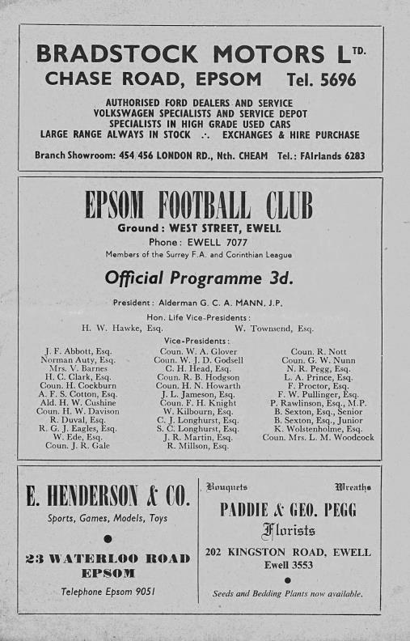
70 years ago today we visited the Ekco ground in Southend for a London League match, winning 2-0 there with goals from Fred Chitty and Bill Cutter. Ekco were another works team, connected with the production of radios and early televisions and owned by Mr E.K.Cole, which is where the name of the company came from!

60 years ago this week Tommy Millard scored twice in our 4-0 demolition of Erith & Belvedere in the Corinthian League. Millard had been released by Leatherhead a few weeks previously and Manager Fred Chitty found out about this and that Millard was out in Epsom, so went to find him to get him to sign up. He found him at the corner of Hook Road and East Street but then realised that he didn’t have a pen and had to borrow one from a passer-by! The paperwork was done later that night by the League and Millard played and scored the next day! This was his third match of an opening five match sequence, during which he would score six times. Tommy is now 86 and still lives in Lower Court Road, Epsom with his wife (see programme pictured)

42 years ago today we visited Molesey in the F.A. Vase where we were defeated 2-1 thanks to a very odd goal. Their player was offside and the flag went up from the Linesman and the referee then blew the whistle, but then overruled himself and allowed the goal to stand!

34 years ago today we hosted Windsor & Eton in the Isthmian League Cup, winning 2-1. In truth we were second best on the night, but led early before the visitors equalised. However, a late Steve Hill winner secured our progress and after the game Manager Adrian Hill gave credit to the boys behind the goal as we didn’t stop singing for the entire match!

Centre page for results

Centre page for results

EL Records Premier Challenge Cup
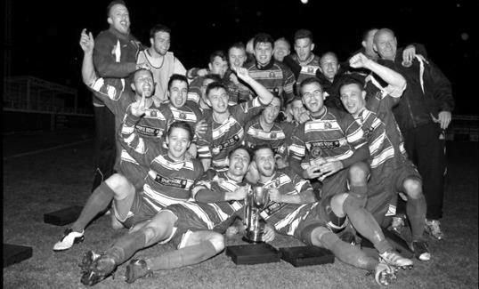
First Round
Camberley Town | 1-3 | Cobham
Horley Town | 0-1 | Chertsey Town
Badshot Lea | 3-1 | Walton & Hersham
FC Deportivo Galicia | 4-1 | Cove
Chessington & Hook United | 2-4 | AFC Hayes
Farnham Town | 1-2 | Southall
Hanworth Villa | 3-1 | Kensington Borough
Second Round
Bedfont & Feltham | 2-0 | Tooting Bec
Sheerwater | 1-0 | Balham
Ash United | 2-3 | Fleet Spurs
Frimley Green | 0-2 | Guildford City
Godalming Town | 2-0 | Dorking Wanderers Reserves
Abbey Rangers | 3-0 | Redhill
FC Deportivo Galicia | 5-0 | AC London
Cobham | 0-3 ABAN 88 | AFC Hayes
CB Hounslow United | 4-1 | Badshot Lea
Hanworth Villa | 2-1 | Sandhurst Town
Epsom & Ewell | 1-0 | Bagshot
Sutton Common Rovers | 4-2 | Southall
Chertsey Town | 3-2 | British Airways
Eversley & California | 1-5 | Knaphill
Banstead Athletic | 4-3 | Colliers Wood United
Spelthorne Sports | 2-1 | Raynes Park Vale

Player Sponsorship
Here is the latest list for 2018/19, with new photos showing all of our players and Management that are available for sponsorship.

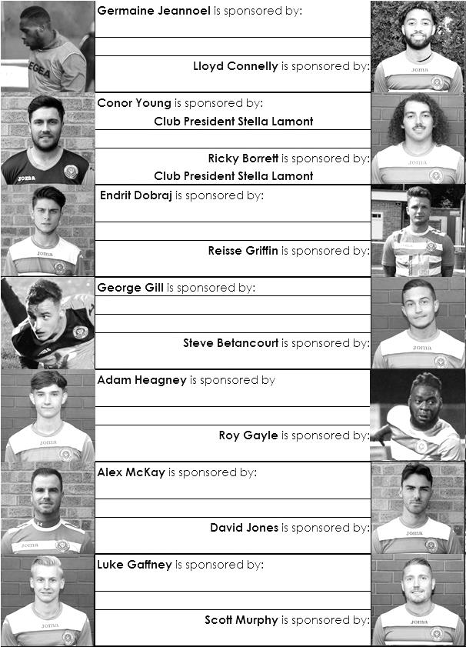

Sponsorship costs just £40 and it is easy to do. Just select a player who has not been previously sponsored and let a Committee Member know that you would like to sponsor them. Beware though. Until we have received the money it is possible for someone to jump in front of you, so don’t delay, sponsor today!
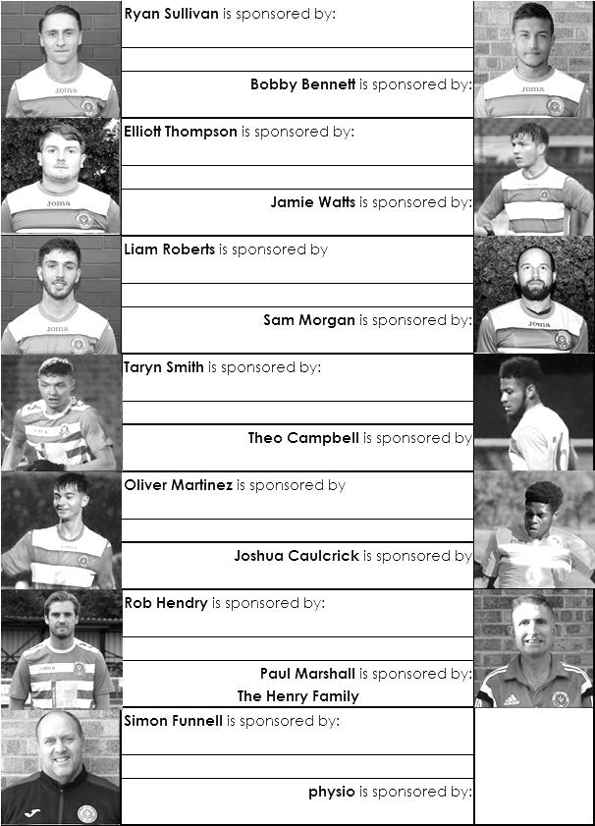

Match and Ball Sponsorships – 2018/19
Opponent | Date | Match Sponsor | Ball Sponsor
Chessington & Hook Utd | 21/08/18 | Club President - Stella Lamont
Beckenham Town (FAC) | 28/08/18 | Building Shop Ltd
Cove | 08/09/18 | EEFC Management Committee
Tooting Bec | 15/09/18 | Building Shop Ltd
Bagshot (LC) | 25/09/18
Sheerwater | 06/10/18 | Paul Merritt
Knaphill U23  (Surrey Premier Cup) | 23/10/18 | Jack Jarman
Frimley Green | 03/11/18 | Our Chairman’s Grandchildren – George, Joseph, Ezara and Inaya
Sandhurst Town (LD1C) | 06/11/18 | Richard Lambert
Kensington Borough | 17/11/18 | Jeff & Arnold Pye
Dorkinian (SPC) | 20/11/18
Dorking Wanderers Res | 27/11/18
Godalming Town | 01/12/18
Bedfont & Feltham | 08/12/18
Eversley & California | 29/12/18
Ash United | 12/01/19
Bagshot | 19/01/19
Farnham Town | 02/02/19
British Airways | 16/02/19
AC London | 02/03/19
FC Deportivo Galicia | 12/03/19
Fleet Spurs | 06/04/19
Sandhurst Town | 20/04/19 | Club President - Stella Lamont
Unknown (LC) |  | 3rd Round – might be at home
Unknown (LD1C) |  | 3rd Round – might be at home
Match sponsorship costs just £60.00!

Sponsorship includes:

Admission, programmes and hospitality for three people.

A full page advert in the programme and mascot for the day (if required).

If you are interested, just speak to a Committee Member,
or drop me an email at: richard.c.lambert@gmail.com

Amateur Football Combination - Premier Division
inc Saturday  17th November | P | W | D | L | F | A | Pts | GD
Old Hamptonians | 9 | 8 | 0 | 1 | 31 | 4 | 24 | +27
Old Meadonians | 9 | 7 | 1 | 1 | 30 | 11 | 22 | +19
Honourable Artillery Company | 9 | 6 | 2 | 1 | 28 | 11 | 20 | +17
Dorkinians | 8 | 5 | 1 | 2 | 25 | 22 | 16 | +3
Old Wokingians | 10 | 3 | 2 | 5 | 19 | 23 | 11 | -4
Wandsworth Borough | 6 | 3 | 1 | 2 | 10 | 9 | 10 | +1
Old Thorntonians | 8 | 3 | 1 | 4 | 20 | 24 | 10 | -4
Old Suttonians | 8 | 3 | 1 | 4 | 22 | 28 | 10 | -6
UCL Academicals | 8 | 2 | 0 | 6 | 15 | 31 | 6 | -16
Southgate Olympic | 10 | 1 | 0 | 9 | 10 | 34 | 3 | -24
Old Parmiterians | 7 | 0 | 1 | 6 | 7 | 20 | 1 | -13

Dorkinians – History
Dorkinians AFC was formed in 1930 as Old Dorkinians AFC (the Old Boys of Dorking Grammar School - now The Ashcombe School).

Over the years, the Club has grown significantly, and now runs six adult sides on a Saturday.

The Club is based in Pixham Lane, Dorking and prides itself on providing football for all in the local area, also successfully running 17 Youth Teams.

For the last five seasons, Dorkinians have been awarded the AFA Charter Standard Development Club of the Year.

Our First Team have progressed significantly over the past few seasons, finishing second last year in the Amateur Football Combination Premier Division - the largest set of adult leagues in England. Last season also saw the side pick up their first AFA Senior Cup, winning the Surrey & Kent Senior Cup in May last year.

After narrowly losing to Corinthian Casuals in this competition last year, Dorkinians are hoping to string together a strong cup run this time around.

Surrey Premier Cup – Second Round
Tuesday, 20th November 2018 - Kick-off 7.45 p.m.
Epsom and Ewell  (Royal Blue & White hoops) | V |  | Dorkinian F.C  (Yellow with Green Sleeves)
Squad | NUMBERS |  | Squad
Conor Young |  |  | Henry Warne ©
Ricky Borrett |  |  | Mike Wills
Luke Elgar |  |  | Alex Wills
Reisse Griffin |  |  | Seth Clenaghan
Lloyd Connelly |  |  | Andy Higgins
Jamie Watts |  |  | James Herouvin
Steve Betancourt |  |  | Liam Hawkins
David Jones |  |  | Will Westcott
Endrit Dobraj |  |  | Matt Morley
Adam Heagney |  |  | James Ellenger
Ryan Sullivan |  |  | Tom Deeks
Liam Roberts |  |  | Tom Neville
© Scott Murphy |  |  | Oli Wayne
Scott Elgar |  |  | Matt Evans-Claus
Elliott Thompson
Bobby Bennett
Rob Hendry
Roy Gayle
Olly Martinez
Germaine Jeannoel
Joshua Caulcrick
Taryn Smith
Simon Funnell | MANAGER |  | Henry Warne
Matt Drew | ASST MANAGER
Sam Morgan | COACHES
 | PHYSIO
REFEREE: C.Peter
ASSISTANTS: M.Ford, I.Hempel

OUR NEXT VISITORS TO HIGH ROAD
Dorking Wanderers Reserves
Combined Counties League – Division One
Tuesday, 27th November 2018 – 7.45 pm

